KENDRIYA VIDYALAYA LUMDING(2015 – 2016)

FORMATIVE ASSESSMENT – III

CLASS – IVSUB: EVS

TIME: 1 $\frac{1}{2}$ HOURS MAX.MARK: 40

NAME OF THESTUDENT___________________________________

CLASS: _________ ROLL NO: ________DATE: ____________

Signature of Invigilator signature of Examiner

EVALUATION TABLE

|  |  |  |
| --- | --- | --- |
| COMPETENCY | VALUE POINTS | GRADE OBTAINED |
| 1. Observation and Reporting (10 ) |  |  |
| 1. Identification and Classification (15) |  |  |
| C) Discovery of Facts (15) |  |  |
| TOTAL – 40 |  |  |

Observation and Reporting (10 )

**Q.1 Observe and identify these following pictures and write their Names. (6x1=6)**

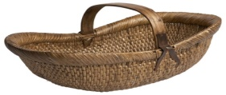

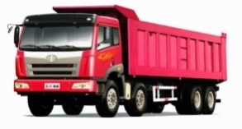………………………………………… ………………...…………………

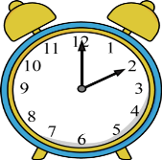

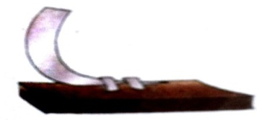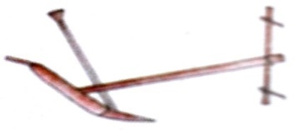 …………………………………… ………………………………

……………………………………… ……………………………………

**Q.2 Where does the water come from in your house . (1x2=2)**

**………………………………………………………………………………………………………………………**

**Q .3Write name of three animals who live on tree. (1x2=2)**

**………………………… ……………………………………….. ……………………………..**

**Identification and Classification (15)**

**Q.4 After read given statement give answer in YES or NO. (4x1=4)**

**(a) Are there are separate toilet in your school for boys and girls . …………. .**

**(b) Is there water in toilet in your school . ………….. .**

**(c) Is there water for washing hands near the toilet . ………….. .**

**(d) Are the toilet smells so bad . …………… .**

**Q.5 Pick out living things from given things . (1x2=2)**

**Rat, paper, crow, fish, tube, parrot, dear, baby, dog, tree, alarm.**

**…………………………………………………………………………………………………………………………………………**

**Q.6 How far are these from your house? (1x2=2)**

|  |  |  |
| --- | --- | --- |
|  | **Minutes to walk** | **In kilometers** |
| **Bus stop** |  |  |
| **School** |  |  |
| **Market** |  |  |
| **Post office** |  |  |
| **Hospital** |  |  |
| **Railway station** |  |  |

**Q .7 Who go to Mandi. (1x2=2)**

**……………………………………………………………………………………………………………………………………..**

**Q.8 Match the following :- (5x1=5)**

**National bird of India Tiger**

**National animal of India New Delhi**

**Capital of India Dispur**

**Capital of Assam Peacock**

**National flower of India Lotus**

**Discovery of Facts (15)**

**Q.9 Fill given words in blanks. (6x1=6)**

**Belvanika, Farmer, Khunti, Kurige, Truck, 450**

1. **Basva’s father is a …………………………….**
2. **Basva leaves in ……………………………. Village.**
3. **………………………… is an iron-road.**
4. **…………………………. Is used to sprinkling the seeds.**
5. **…………………………… is used to take onions to market.**
6. **Number of boys in your school is ………………………….**

**Q.10 Write two use of water . (1x2=2)**

**Q.11Nandita used to feel like vomiting when at first she had to use the**

**toilet where Mama lived.Why? (1x2=2)**

**Q.12 Draw a colourful picture of banyan tree. (1x5=5)**